**R.Rohith Rajagopalan**

**1001518031**

**Race Condition Vulnerability Lab**

**Initial Setup**

First we disable the built in protection scheme against race condition.We compile the given vulnerable code and make it a set UID program

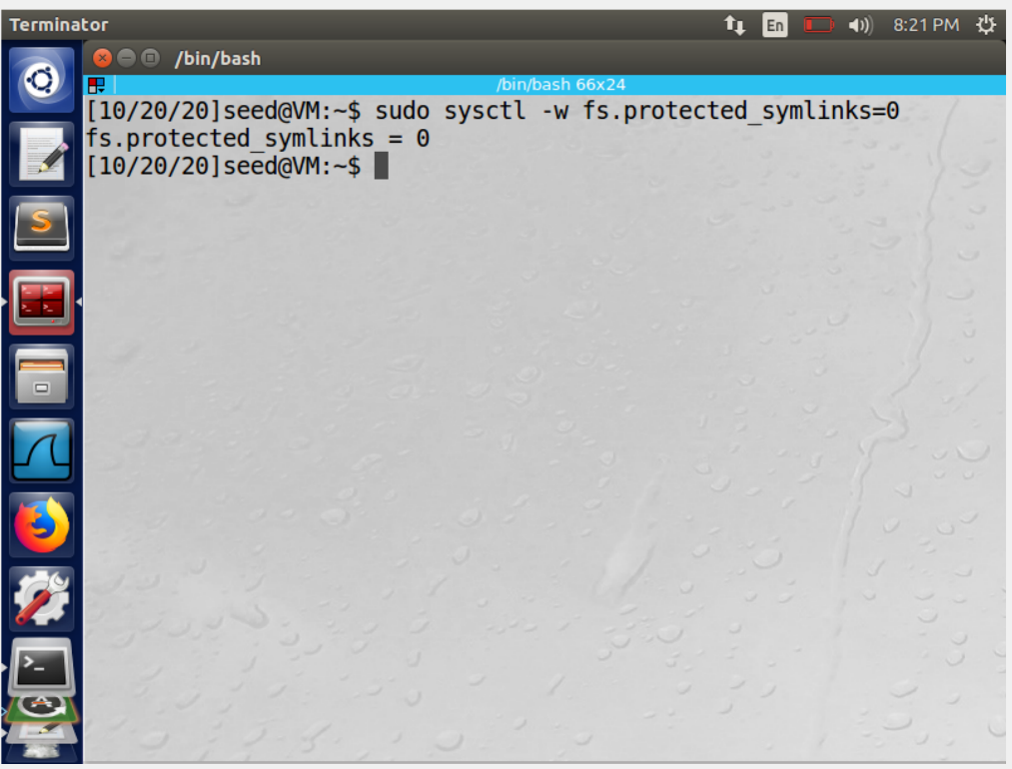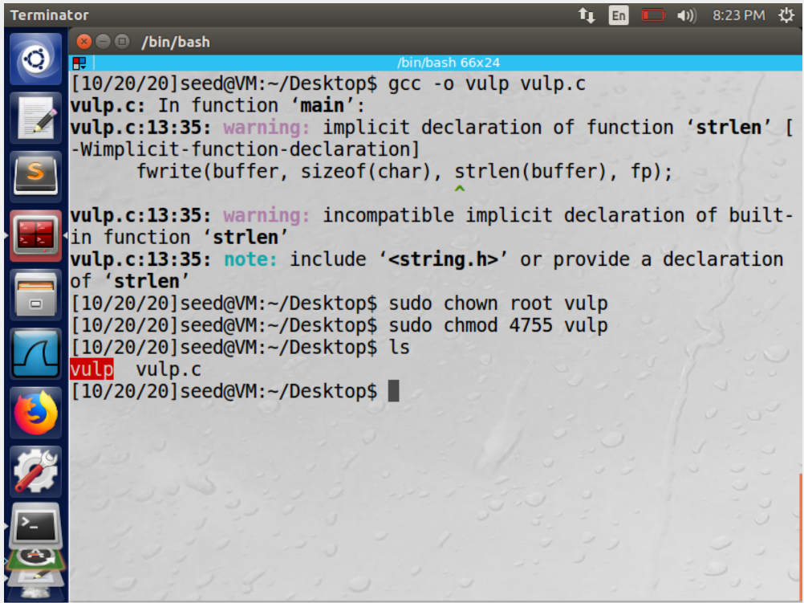

**Task 1: Choosing Our Target**

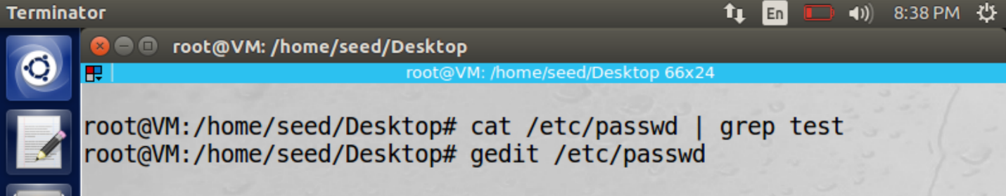

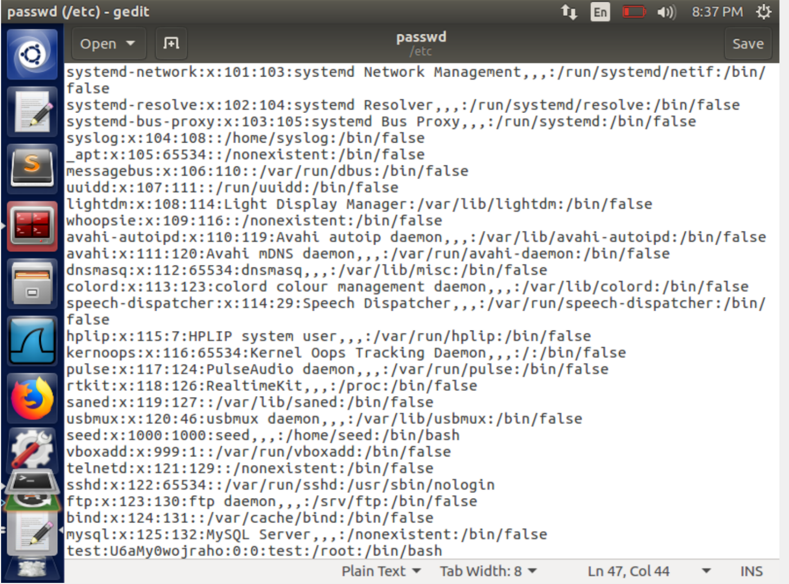

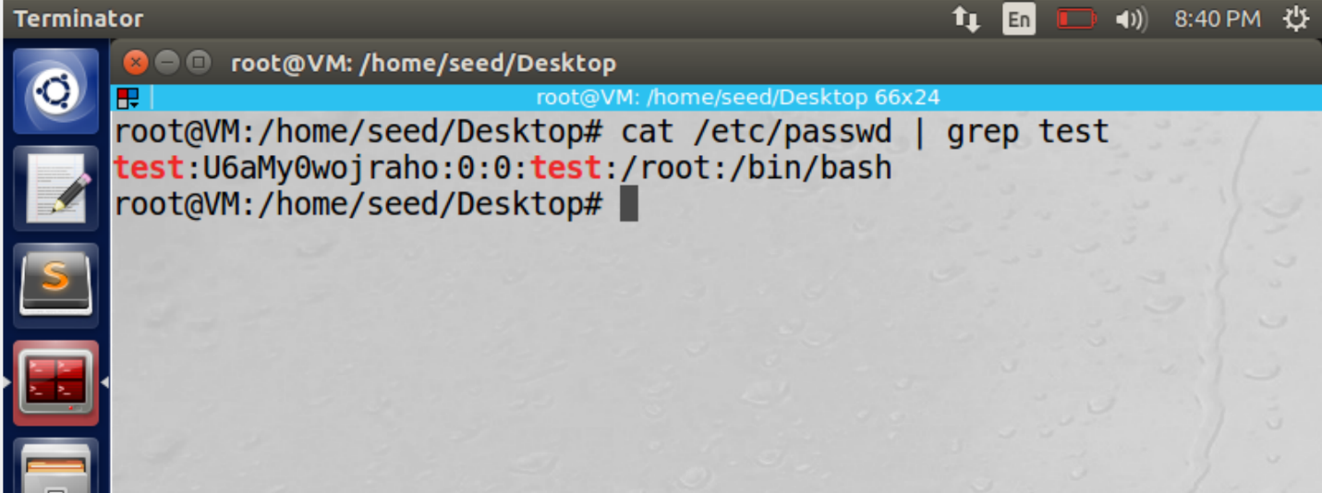

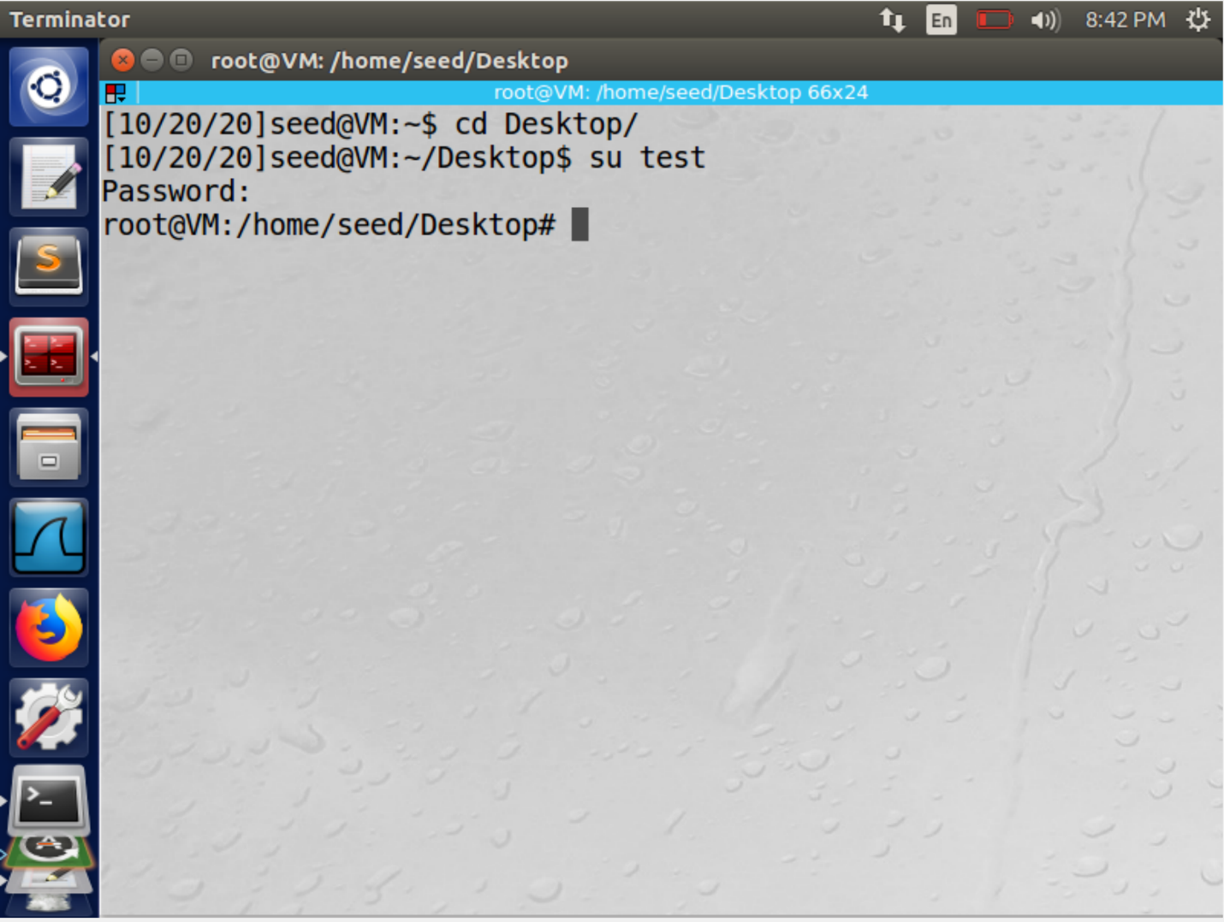

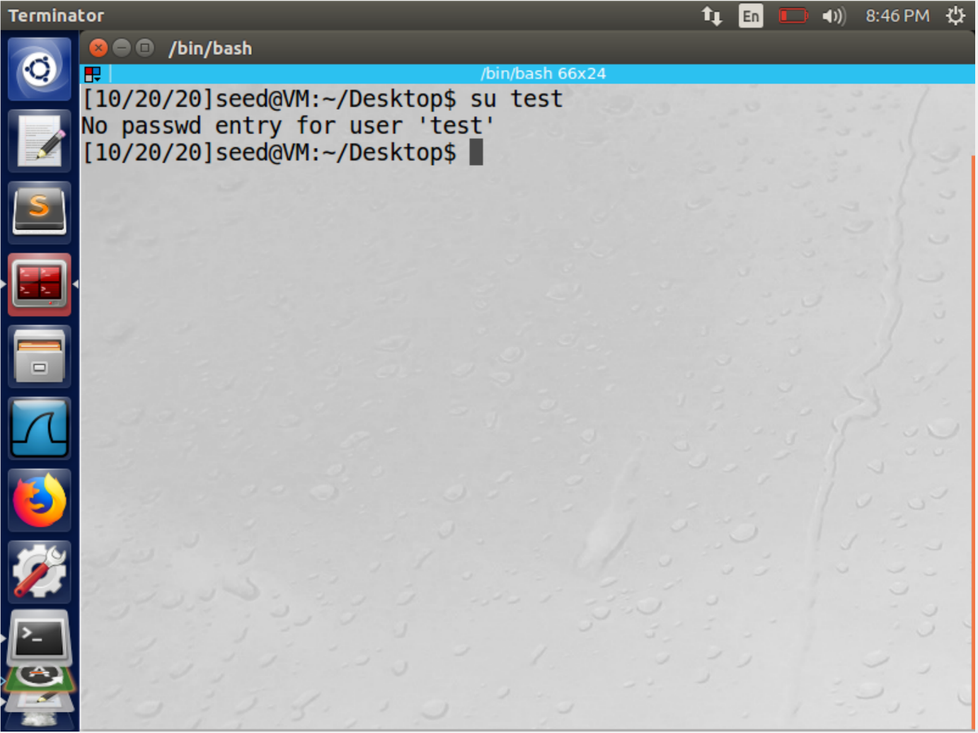

first we check if there is any user by the name of test, we then manually enter the given string in the. /etc/passwd file and repeat the same process. We find out that the user test is present after we enter the string in the password file. We try to login as the user test. We press enter without entering anything when asked for the password. The # sign indicates that we have got the root access.

We then delete the string we entered in the /etc/passwd file.

**Task 2: Launching the Race Condition Attack**

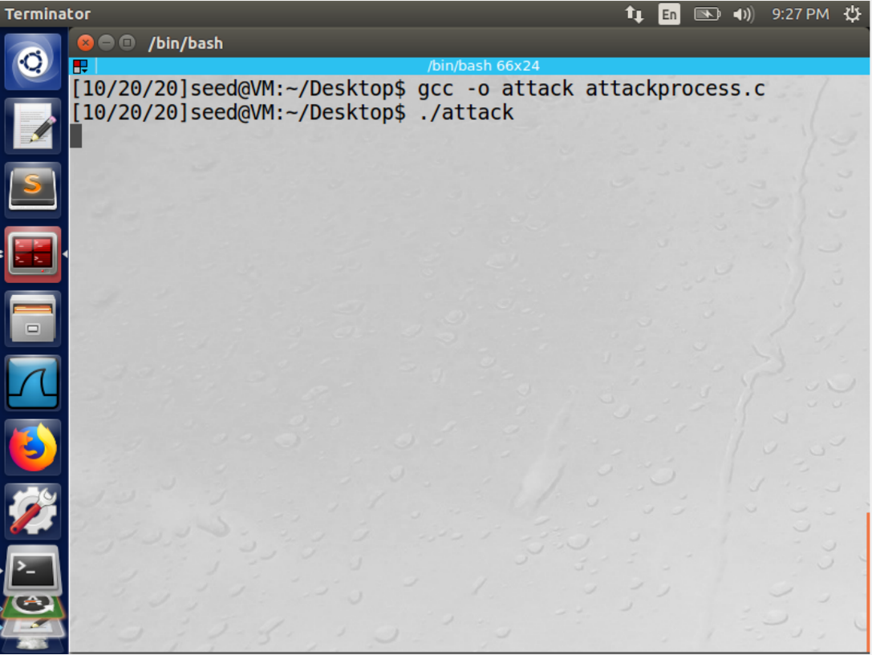

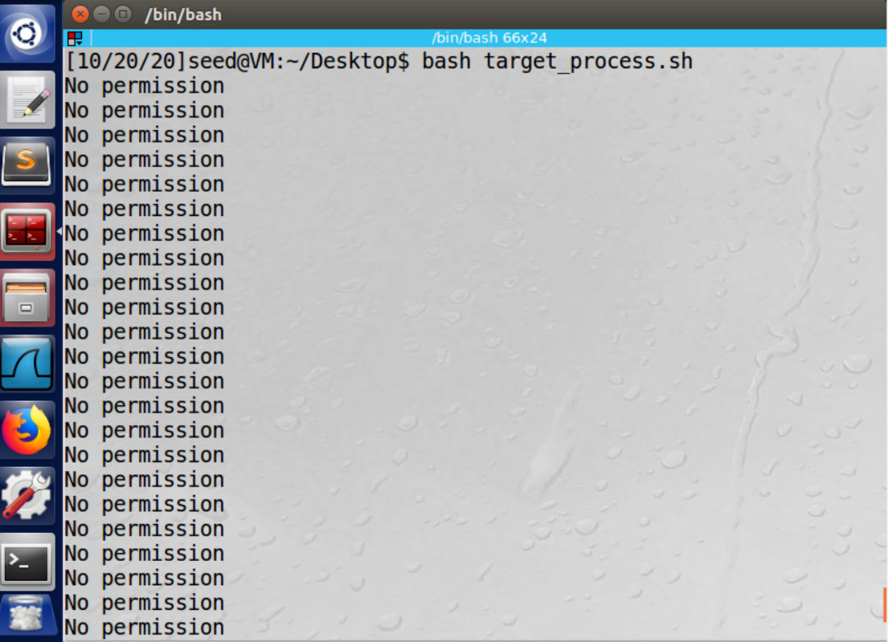

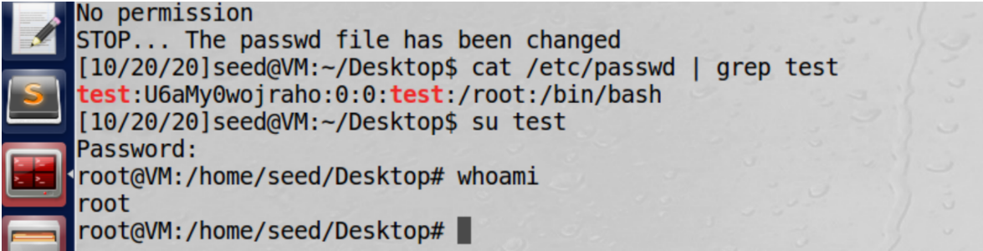

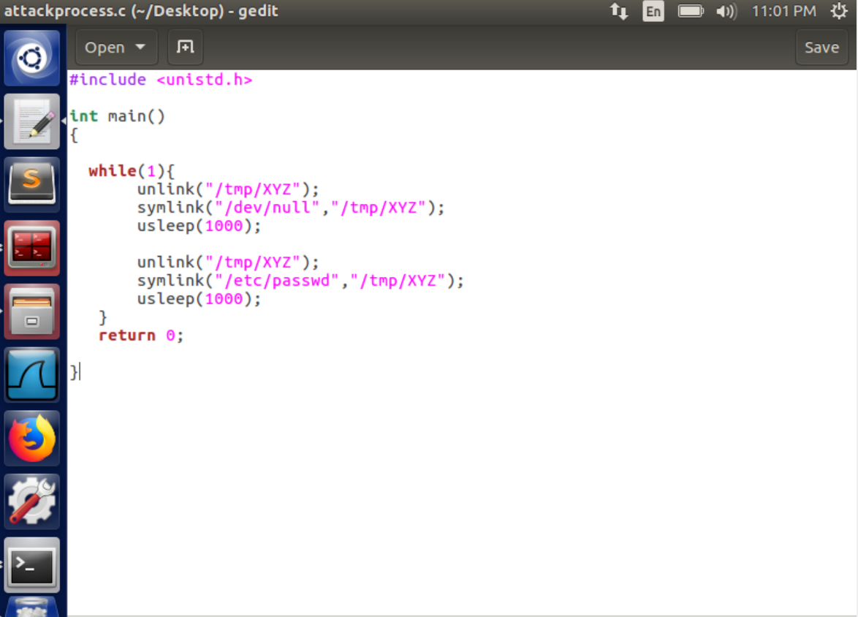

Here we try and exploit the race condition. In order for the race condition to be executed we need to run two process concurrent. First we run our target_process program runs our vulnerable vulp code in a loop until the password is changed. The input is taken from the file "input" which has the same string we used for task 1. The attack file is run in parallel to the target_process. This code aims to alter where the "tmp/XYZ" points to.

First the attack file is compiled and run the. The target_process file is run. The program runs in a loop untill the specified condition is met, after which it stops and breaks the loop. At this point we can say that the password has changed.

We check this by seeing if the user test is present in the etc/passwd file and then try to log in as the user with the name test. We repeat the same process similar to task 1 and press enter when the password is requested. The # sign indicates that we have got the root access

**Task 3: Countermeasure: Applying the Principle of Least Privilege**

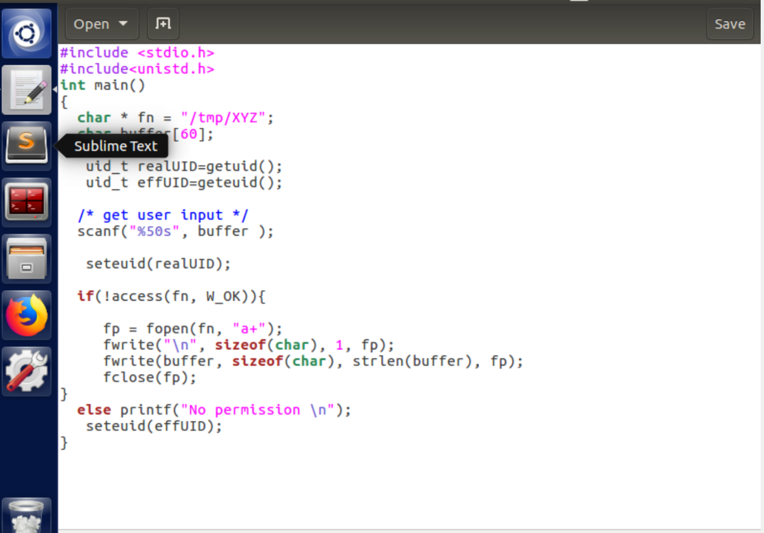

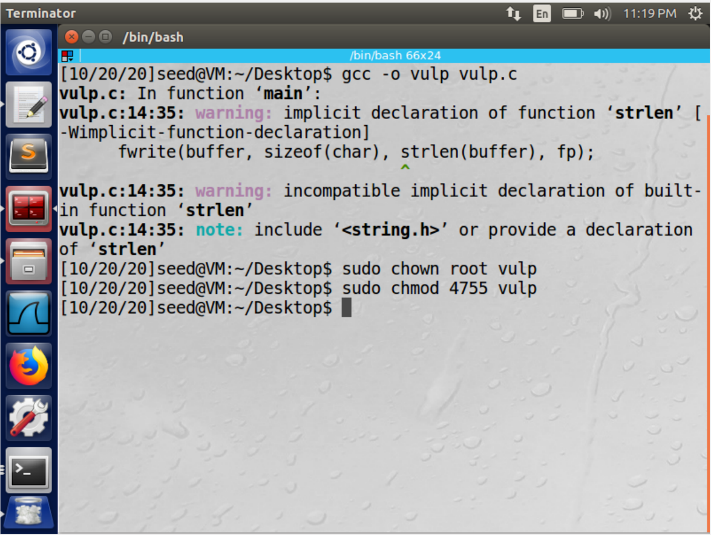

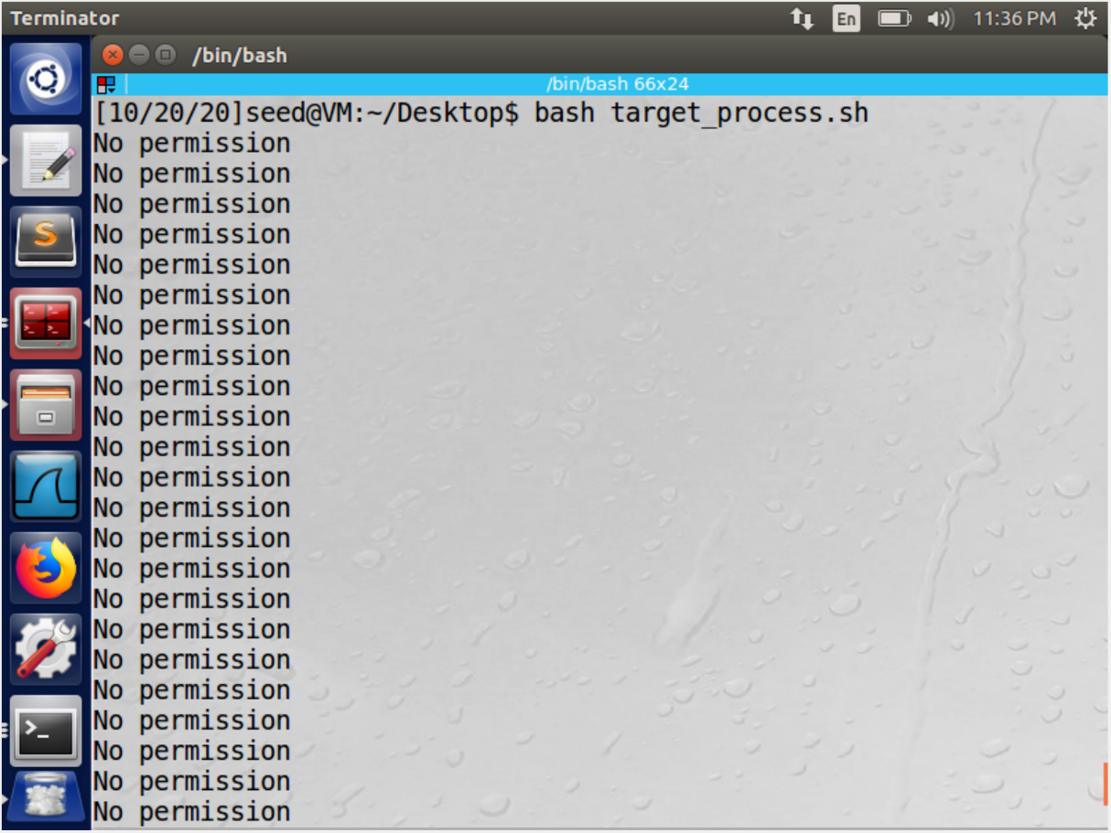

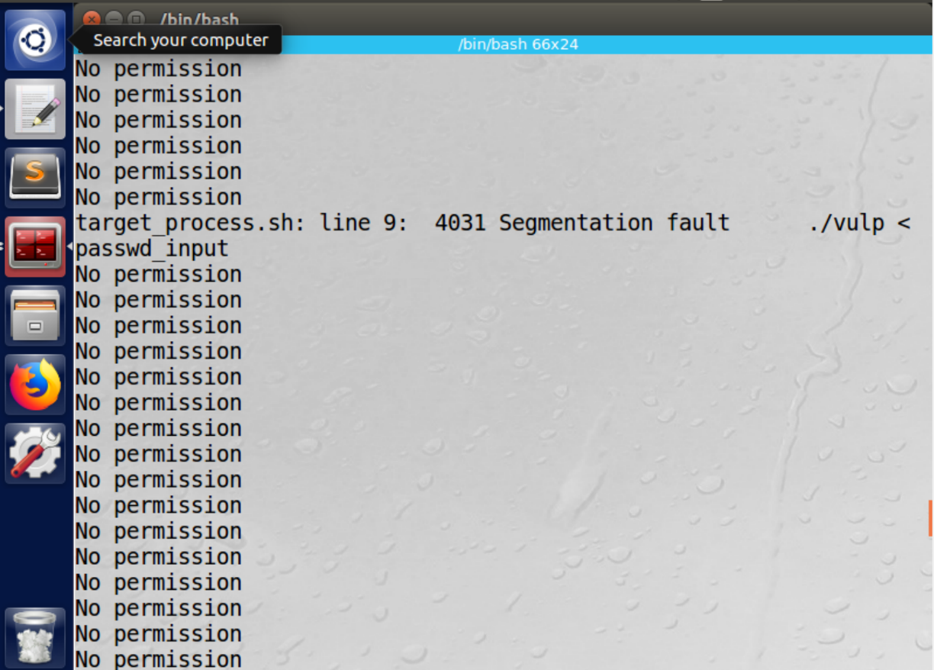

We will use the principle of least privilege. First we set the effective user ID to real user id . At the end of the program we change the effective user id to what it was initially. This results in the drop of privileges first and then regaining of the dropped privileges. We follow the same process as before. We realize that the attack is not successful. This is because on following the principle of least privileges the privilege of the set UID program is temporarily discarded because the effective user id is set to that one of the real userid. The fopen program cannot open the privileged file /etc/passwd because the effective user id is that of the seed and this does not have the privilege to open the file. By setting effective user id to real user id we can remove the extra unnecessary privileges

**Task 4: Countermeasure: Using Ubuntu’s Built-in Scheme**

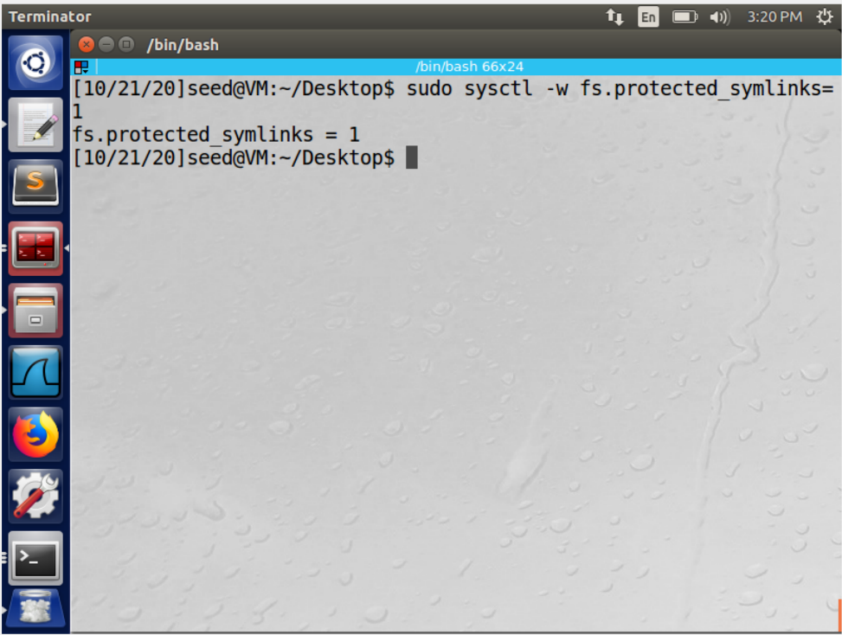

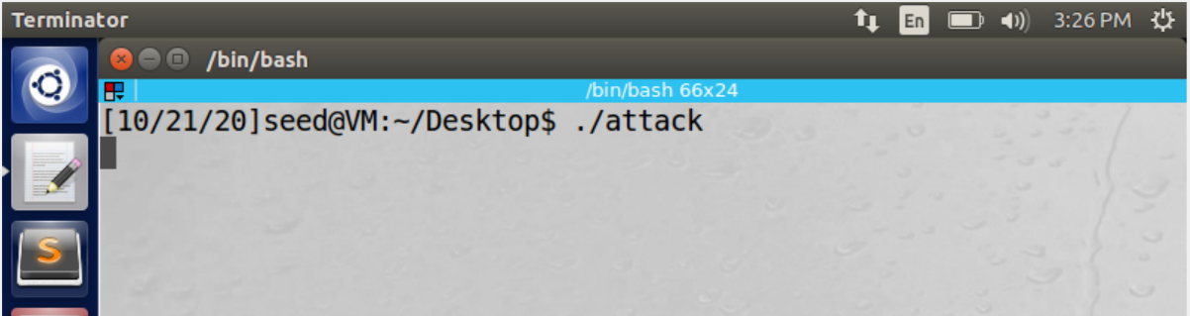

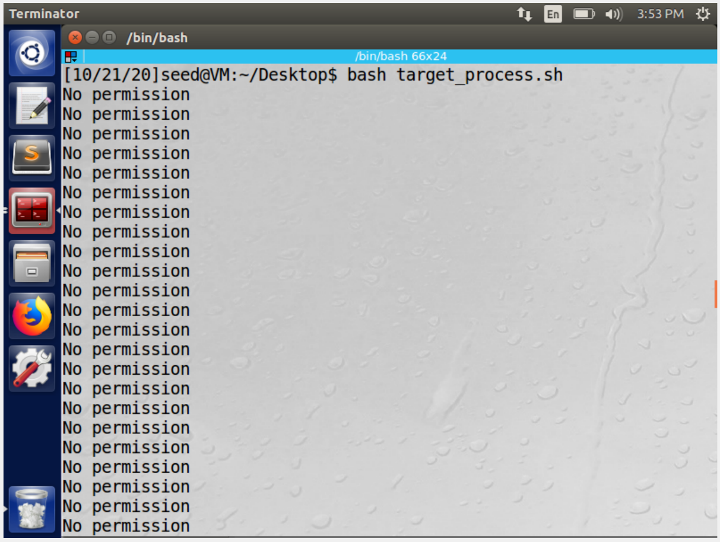

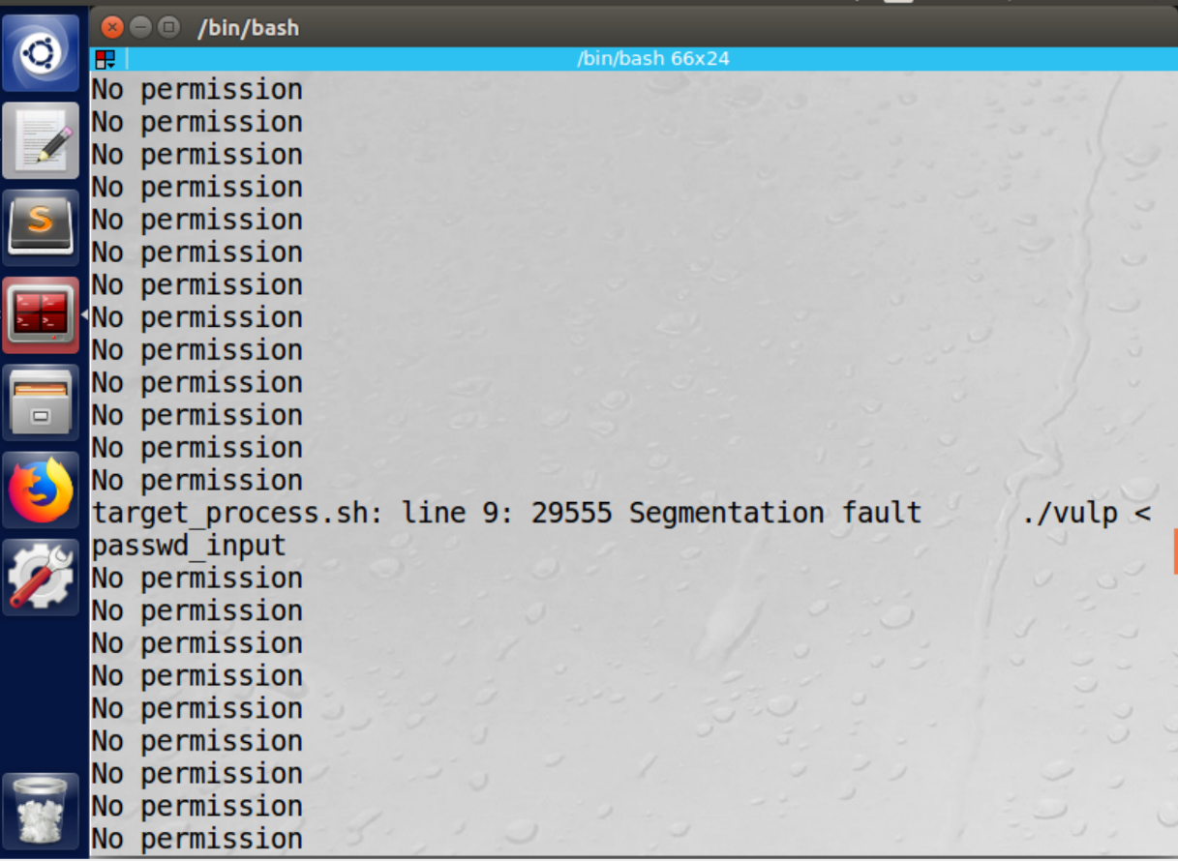

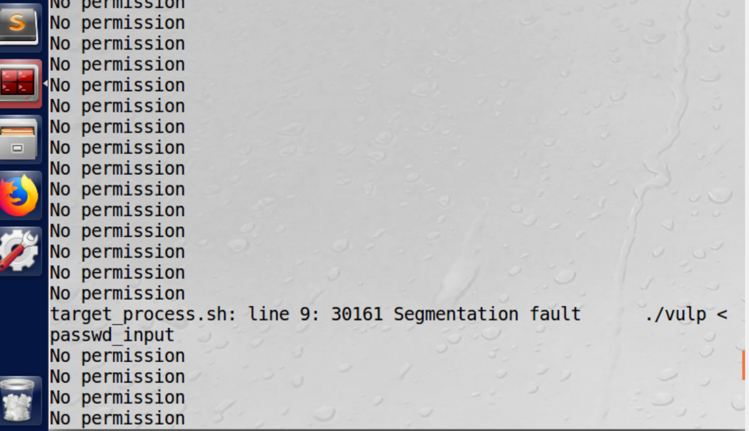

We remove the least privileges conditions from the program . Then we recompile it and make it a setuid program.We then enable the inbuilt protection against race condition. We go ahead and perform the attack like we did earlier. We see that the we get no permission and segmentation faults as the error in a loop. This our attack is not successful

**Q1) How does this protection scheme work?**

Here the race condition vulnerability is based on exploiting the symbolic links inside the /tmp directory. Thus preventing programs from following symbolic links might over come this vulnerability. This is what the inbuilt prevention technique does. Therefore by preventing the modification of the file symbolic links it helps in preventing the race condition

**Q2) What are the limitations of this scheme?**

This protection scheme does not stop the race condition from taking place, but just prevents it from causing damage. Thus it's an access control mechanism that's good for controlling the access to files. This protection also applies to only word writable sticky directories such as temp and not other types of directories

**References**

https://github.com/Catalyzator/SEEDlab/blob/master/RaceConditionVulnerability.pdf